Industrial Internship Report on
Prediction of Agriculture Crop Production in India
Prepared by
Saismith Sahoo

Executive Summary
This report provides details of the Industrial Internship provided by upskill Campus and The IoT Academy in collaboration with Industrial Partner UniConverge Technologies Pvt Ltd (UCT).
This internship was focused on a project/problem statement provided by UCT. We had to finish the project including the report in 6 weeks’ time.
My project was (Tell about ur Project)
This internship gave me a very good opportunity to get exposure to Industrial problems and design/implement solution for that. It was an overall great experience to have this internship.

TABLE OF CONTENTS
1 Preface 3
2 Introduction 4
2.1 About UniConverge Technologies Pvt Ltd 4
2.2 About upskill Campus 8
2.3 Objective 9
2.4 Reference 9
2.5 Glossary 10
3 Problem Statement 11
4 Existing and Proposed solution 12
5 Proposed Design/ Model 13
5.1 High Level Diagram (if applicable) 13
5.2 Low Level Diagram (if applicable) 13
5.3 Interfaces (if applicable) 13
6 Performance Test 14
6.1 Test Plan/ Test Cases 14
6.2 Test Procedure 14
6.3 Performance Outcome 14
7 My learnings 15
8 Future work scope 16

Preface
Summary of the whole 6 weeks’ work.
About need of relevant Internship in career development.
Brief about Your project/problem statement.
Opportunity given by USC/UCT.
How Program was planned
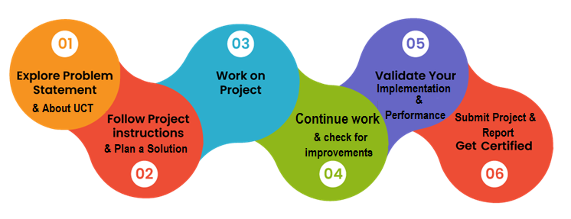
Your Learnings and overall experience.
Thank to all (with names), who have helped you directly or indirectly.
Your message to your juniors and peers.

Introduction

About UniConverge Technologies Pvt Ltd
A company established in 2013 and working in Digital Transformation domain and providing Industrial solutions with prime focus on sustainability and RoI.
For developing its products and solutions it is leveraging various Cutting Edge Technologies e.g. Internet of Things (IoT), Cyber Security, Cloud computing (AWS, Azure), Machine Learning, Communication Technologies (4G/5G/LoRaWAN), Java Full Stack, Python, Front end etc.
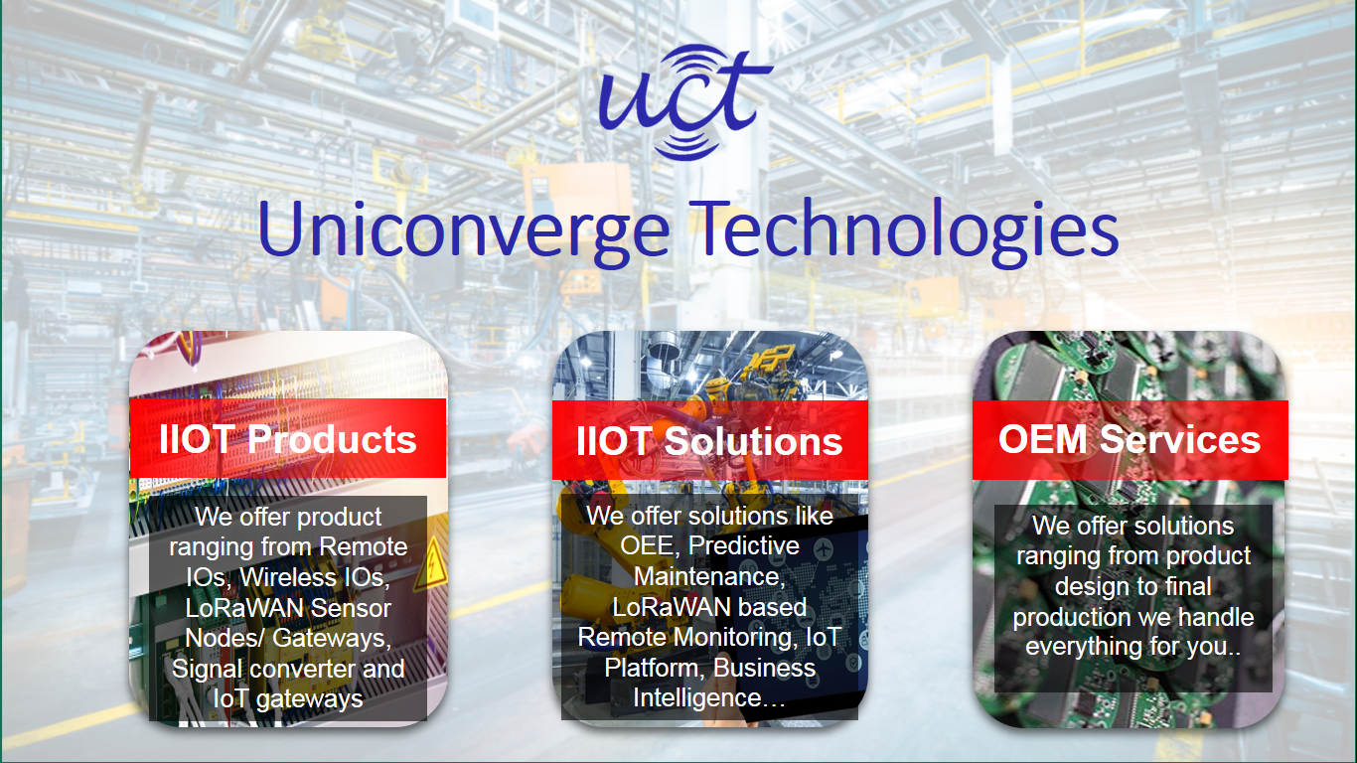
- UCT IoT Platform ()
UCT Insight is an IOT platform designed for quick deployment of IOT applications on the same time providing valuable “insight” for your process/business. It has been built in Java for backend and ReactJS for Front end. It has support for MySQL and various NoSql Databases.
- It enables device connectivity via industry standard IoT protocols - MQTT, CoAP, HTTP, Modbus TCP, OPC UA
- It supports both cloud and on-premises deployments.
It has features to
• Build Your own dashboard
• Analytics and Reporting
• Alert and Notification
• Integration with third party application(Power BI, SAP, ERP)
• Rule Engine

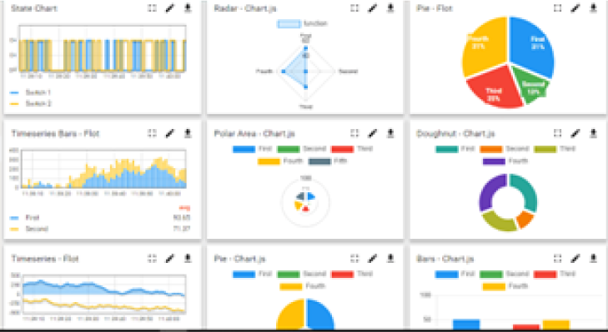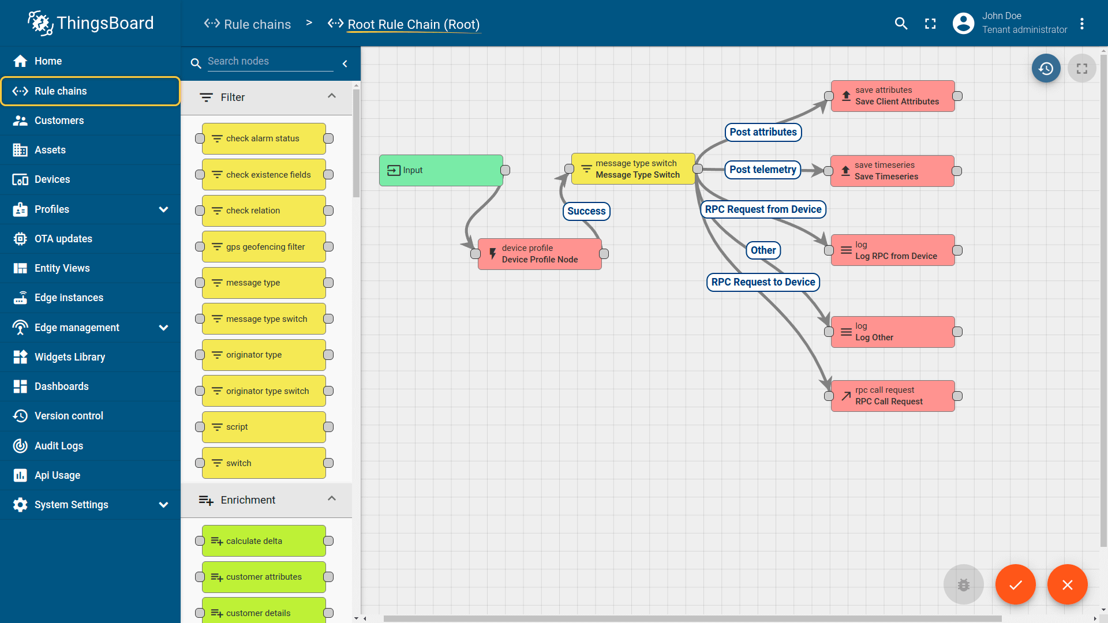

- Smart Factory Platform ()
Factory watch is a platform for smart factory needs.
It provides Users/ Factory
- with a scalable solution for their Production and asset monitoring
- OEE and predictive maintenance solution scaling up to digital twin for your assets.
- to unleased the true potential of the data that their machines are generating and helps to identify the KPIs and also improve them.
- A modular architecture that allows users to choose the service that they what to start and then can scale to more complex solutions as per their demands.
Its unique SaaS model helps users to save time, cost and money.
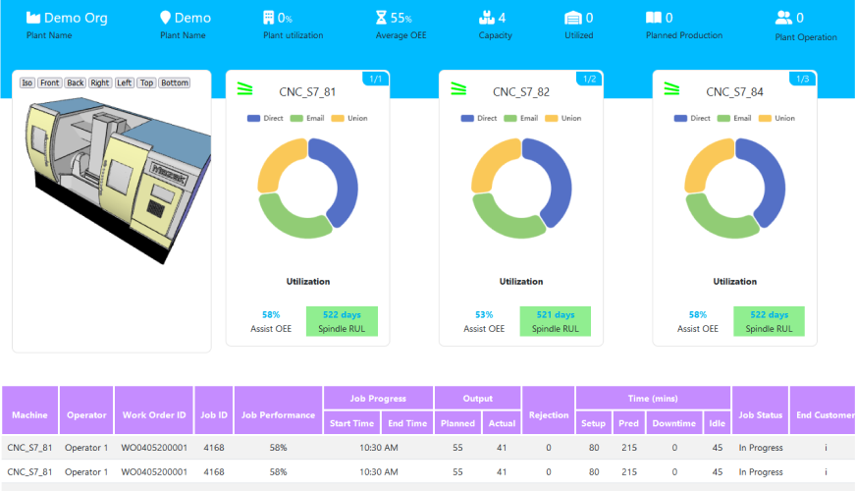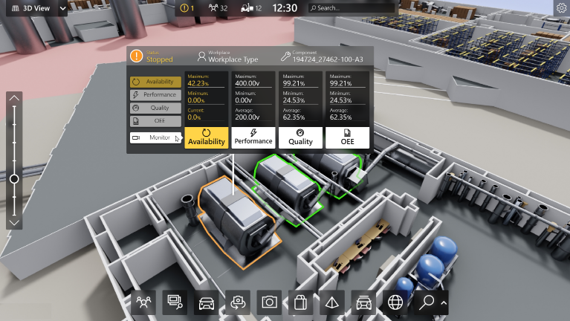

- 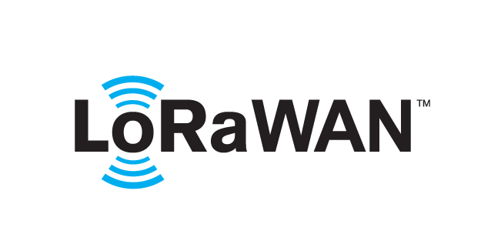 based Solution
UCT is one of the early adopters of LoRAWAN teschnology and providing solution in Agritech, Smart cities, Industrial Monitoring, Smart Street Light, Smart Water/ Gas/ Electricity metering solutions etc.
- Predictive Maintenance
UCT is providing Industrial Machine health monitoring and Predictive maintenance solution leveraging Embedded system, Industrial IoT and Machine Learning Technologies by finding Remaining useful life time of various Machines used in production process.
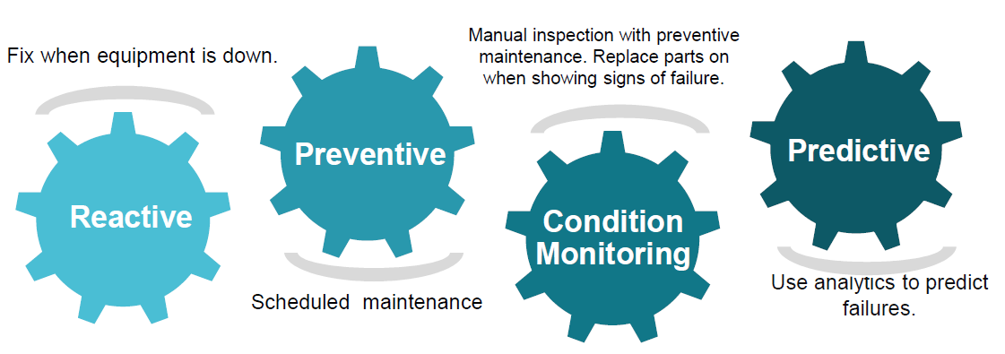

About upskill Campus (USC)
upskill Campus along with The IoT Academy and in association with Uniconverge technologies has facilitated the smooth execution of the complete internship process.
USC is a career development platform that delivers personalized executive coaching in a more affordable, scalable and measurable way.




Seeing need of upskilling in self paced manner along-with additional support services e.g. Internship, projects, interaction with Industry experts, Career growth Services
https://www.upskillcampus.com/
upSkill Campus aiming to upskill 1 million learners in next 5 year

The IoT Academy
The IoT academy is EdTech Division of UCT that is running long executive certification programs in collaboration with EICT Academy, IITK, IITR and IITG in multiple domains.

Objectives of this Internship program
The objective for this internship program was to
☛ get practical experience of working in the industry.
☛ to solve real world problems.
☛ to have improved job prospects.
☛ to have Improved understanding of our field and its applications.
☛ to have Personal growth like better communication and problem solving.

Reference
[1]
[2]
[3]

Glossary
Terms | Acronym

Problem Statement
Agricultural Analytics and Crop Prediction System Using Machine Learning Agriculture plays a significant role in India's economy. Farmers and agricultural organizations often face challenges in estimating crop production and yield accurately. Traditional estimation methods are time-consuming and may not effectively utilize historical agricultural data. The objective of this project is to develop a machine learning-based system capable of predicting crop production and crop yield using historical agricultural datasets. The system helps analyze agricultural trends and provides predictions that can support better planning and decision-making.

Existing and Proposed solution

1. Existing Solution Traditional agricultural forecasting mainly depends on manual analysis, expert knowledge, and statistical methods. These approaches often require extensive effort and may not fully utilize available historical data. Limitations: • Time-consuming analysis. • Lower scalability for large datasets. • Limited ability to discover complex patterns. • Lower prediction accuracy compared to machine learning models. 2. Proposed Solution The proposed solution uses Machine Learning algorithms to predict agricultural outcomes based on historical crop data. The system consists of: 3. Crop Production Prediction Module. 4. Crop Yield Prediction Module. 5. Agricultural Data Analysis and Visualization Module. Machine learning models such as Linear Regression, Decision Tree Regressor, and Random Forest Regressor are trained and evaluated to identify the best-performing model. 6. Value Addition • Automated prediction process. • Faster analysis of agricultural data. • Improved prediction accuracy. • Better understanding of factors affecting crop production and yield

Code submission (Github link)
Project4_Ag_Prediction of Agriculture Crop Production In India/AgriculturePrecdictionSystem.py

Report submission (Github link) : placeholder

Proposed Design/ Model

Given more details about design flow of your solution. This is applicable for all domains. DS/ML Students can cover it after they have their algorithm implementation. There is always a start, intermediate stages and then final outcome.

High Level Diagram (if applicable)

Figure 1: HIGH LEVEL DIAGRAM OF THE SYSTEM

Low Level Diagram (if applicable)

The system follows the following workflow: Agricultural Dataset Collection ↓ Data Cleaning and Preprocessing ↓ Feature Selection and Encoding ↓ Train-Test Split ↓ Machine Learning Model Training ↓ Model Evaluation ↓ Prediction and Analysis 5.1 High Level Diagram (if applicable) Agricultural Data | v Data Preprocessing | Industrial Internship Report Page 15 Industrial Internship Report Page 16 v Feature Engineering | v Machine Learning Models | +----------------+ | | v v Crop Production Crop Yield Prediction Prediction | v Results & Analysis

Interfaces (if applicable)
Update with Block Diagrams, Data flow, protocols, FLOW Charts, State Machines, Memory Buffer Management.

Performance Test

The system was evaluated using R² Score and Mean Absolute Error (MAE).
1. 6.1 Test Plan • Split dataset into training and testing data. • Train three machine learning algorithms. • Compare prediction performance. • Select the best-performing model.
2. 6.2 Test Procedure
3. Load datasets.
4. Preprocess data.
5. Train Linear Regression model.
6. Train Decision Tree model.
7. Train Random Forest model.
8. Evaluate using test data.
9. Compare results.
10. 6.3 Performance Outcome
11. Crop Production Prediction Model R² Score Linear Regression 0.683
Decision Tree 0.323
Random Forest 0.696
Best Model: Random Forest Regressor
12. Model R² Score Linear Regression 0.780
Decision Tree 0.644
Random Forest 0.946
Best Model: Random Forest Regressor The Random Forest model provided the highest prediction accuracy for both modules.

My learnings

During this internship project, I gained practical experience in Data Science and Machine Learning. I learned how to:
• Work with real-world datasets.
• Perform data cleaning and preprocessing.
• Apply feature engineering techniques.
• Train and evaluate machine learning models.
• Interpret model performance metrics.
• Create data visualizations and analytical reports.
• Use Python libraries such as Pandas, NumPy, Matplotlib, and Scikit-Learn. This project improved my problem-solving skills and enhanced my understanding of machine learning applications in agriculture.

Future work scope

The project can be enhanced by incorporating additional agricultural parameters such as:
• Rainfall data
• Temperature data
• Soil quality information
• Irrigation facilities
• Fertilizer usage statistics

Advanced machine learning techniques such as XGBoost, Deep Learning, and real-time agricultural monitoring systems can also be implemented to improve prediction accuracy and system performance.

